Project Report Template

# INTRODUCTION

## Overview

### Build A Employee Travel Approval Application for corporates

##### The project aim is to provide real-time knowledge for all the students who have basic knowledge of Salesforce and Looking for a real-time project. This project will also help to those professionals who are in cross-technology and wanted to switch to Salesforce with the help of this project they will gain knowledge and can include into their resume as well

## Purpose

This Project helps in sending your travel approval requests to your manager in place of emails

1. Real Time Salesforce Project

2. Object & Relationship in Salesforce

# Problem Definition & Design Thinking

## Empathy Map

**Ideation Phase Empathize & Discover**

Date : 13 March 2023

Team ID : NM2023TMIDxxxxx

Project Name :Project – xxx

Maximum Marks :5 Marks

**Empathy Map Canvas:**

An empathy map is a simple, easy-to-digest visual that captures knowledge about a user’s behaviours and attitudes.

It is a useful tool to helps teams better understand their users. Creating an effective solution requires understanding the true problem and the person who is experiencing it. The exercise of creating the map helps participants consider things from the user’s perspective along with his or her goals and challenges.

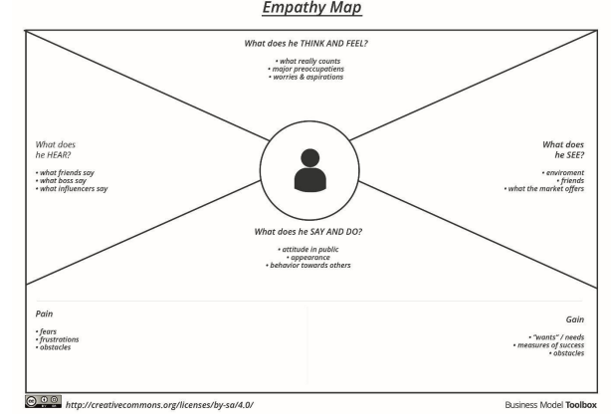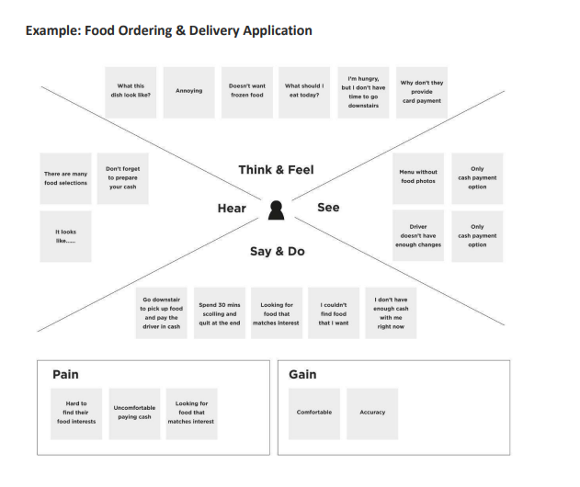

## Ideation & Brainstorming Map

Date : 13 March 2023

Team ID :NM2023TMID00001

Project Name :

Maximum Marks : 5 Marks

**Brainstorm & Idea Prioritization Template:**

Brainstorming provides a free and open environment that encourages everyone within a team to participate in the creative thinking process that leads to problem solving. Prioritizing volume over value, out-of-the-box ideas are welcome and built upon, and all participants are encouraged to collaborate, helping each other develop a rich amount of creative solutions.

Use this template in your own brainstorming sessions so your team can unleash their imagination and start shaping concepts even if you're not sitting in the same room.

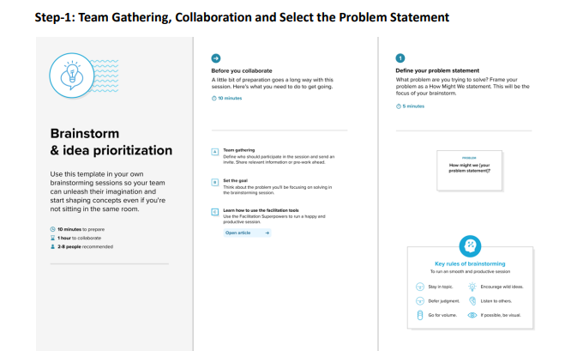

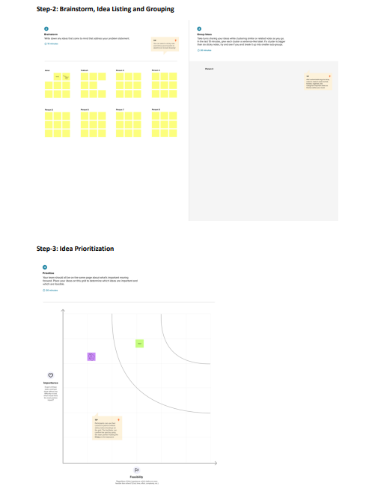

# RESULT

## Data Model

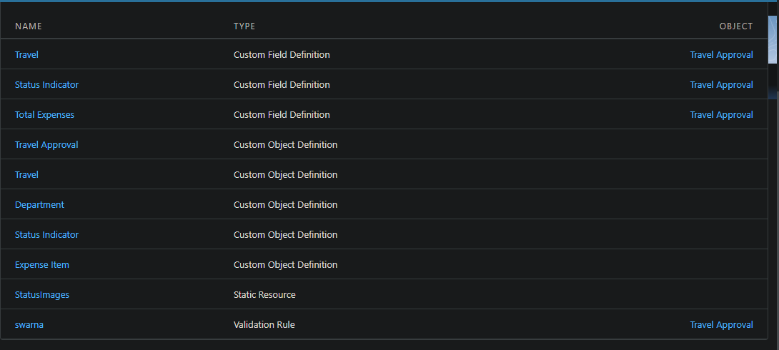

## 3.2 Activity & Screenshot

**Milestone 1- Create Salesforce Org**:

**Introduction**

Are you new to Salesforce? Not sure exactly what it is, or how to use it? Don’t know where you should start on your learning journey? If you’ve answered yes to any of these questions, then you’re in the right place. This module is for you.

Welcome to Salesforce! Salesforce is game-changing technology, with a host of productivityboosting features, that will help you sell smarter and faster. As you work toward your badge for this module, we’ll take you through these features and answer the question, “What is Salesforce, anyway?”

**What Is Salesforce?**

Salesforce is your customer success platform, designed to help you sell, service, market, analyze, and connect with your customers.

Salesforce has everything you need to run your business from anywhere. Using standard products and features, you can manage relationships with prospects and customers, collaborate and engage with employees and partners, and store your data securely in the cloud.

So what does that really mean? Well, before Salesforce, your contacts, emails, follow-up tasks, and prospective deals might have been organized something like this:

**Activity-1:**

**Creating Developer Account**

Creating a developer org in salesforce.

1. Go to developers.salesforce.com/

2. Click on sign up.

3. On the sign-up form, enter the following details:

1. First name & Last name

2. Email

3. Role: Developer

4. Company: College Name

5. County: India

6. Postal Code: pin code

7. Username: should be a combination of your name and company

This need not be an actual email id, you can give anything in the format: [username@organization.com](mailto:username@organization.com)

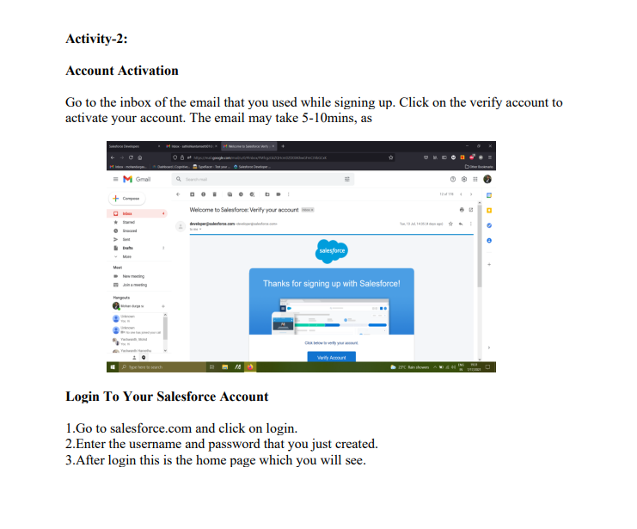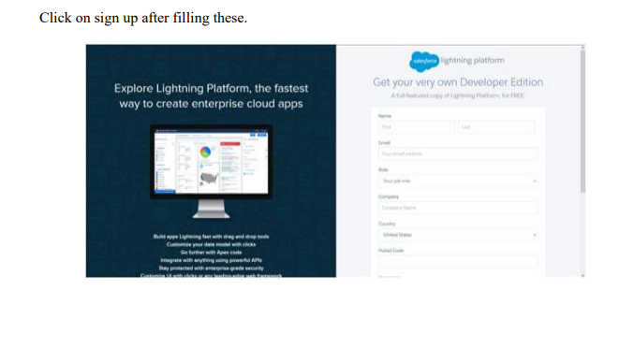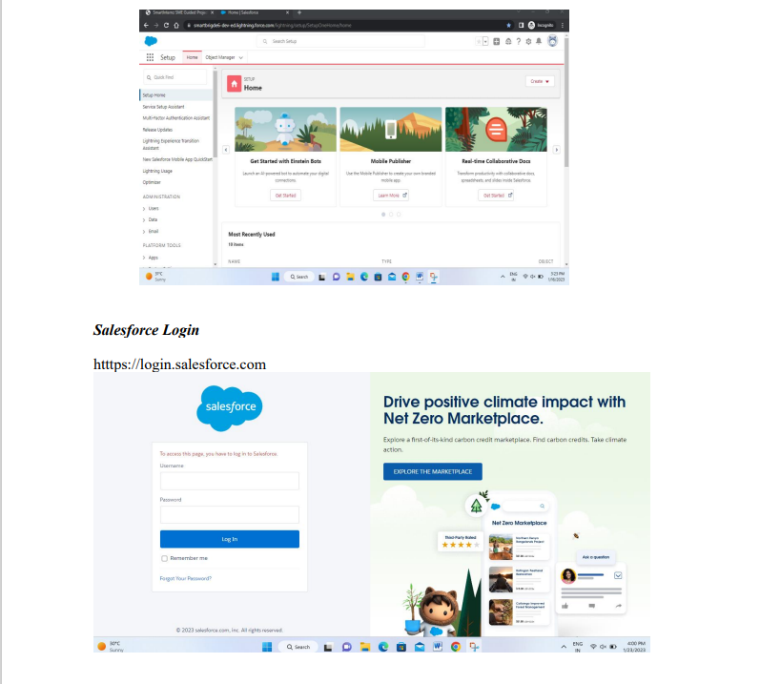

**Milestone 2 Creating the Application:**

The AppManager is your go to place for managing apps for lightning experience. It shows all your connected apps and salesforce apps. Use the lightning experience app manager to view all your salesforce apps.

<https://youtu.be/GR61sx2Kdis>

**Activity-1**:

**Create the Travel Application**

Search AppManager in quick find box, click on new lightning app. Before creating the application download this zip file and extract it.

https://developer.salesforce.com/files/TravelAppWorkshopFiles.zip

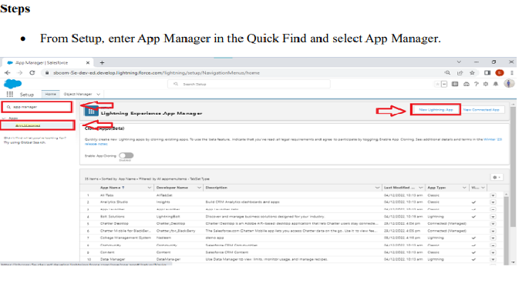

• Click New Lightning App. Enter Travel Approval as the App Name, then click Next

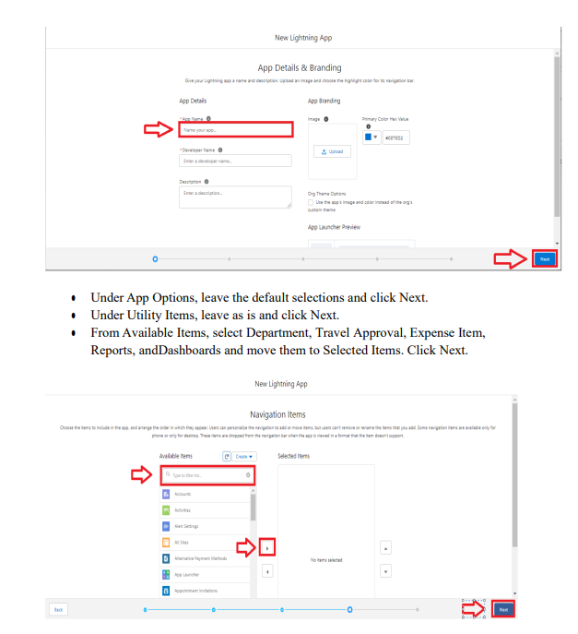

● From Available Profiles, select System Administrator and move it to Selected Profiles.Click Save & Finish

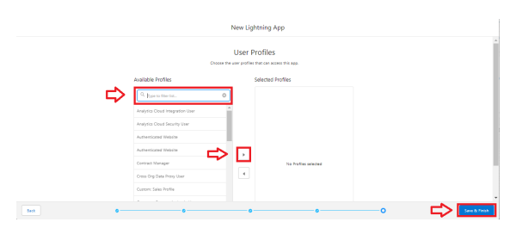

● To verify your changes, click the App Launcher, type Travel Approval and select the Travel Application app.

**Milestone 3** **-What is an object?:**

Salesforce objects are database tables that permit you to store data that is specific to an organization. It consists of fields (columns) and records (rows).

Salesforce objects are of two types:

• Standard Objects: Standard objects are the kind of objects that are provided by salesforce.com such as users, contracts, reports, dashboards, etc.

• Custom Objects: Custom objects are those objects that are created by users. They supply information that is unique and essential to their organization. They are the heart of any application and provide a structure for sharing data.

In this Travel Approval application we will be creating 3 objects:

Department

Travel approval and

Expense Item

**Activity-1:**

**Custom Object Creation**

1.After you Login to your org, click create on the right side of the page and select custom object

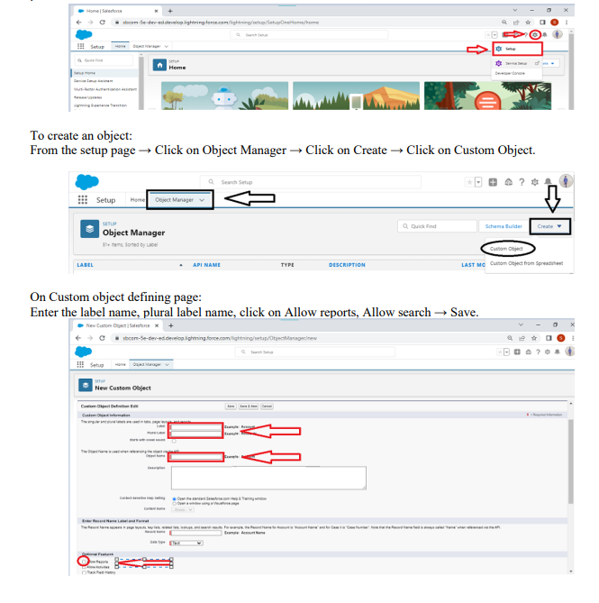

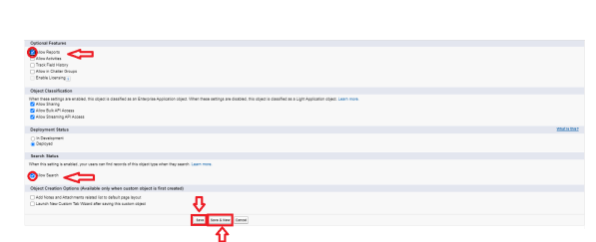

**Activity-2:**

**Create 3 custom objects and tabs**

a) Department

b) Travel Approval

c) Expense Item

**Create Department Object**

1.From Setup, click Object Manager.

2.Click Create, then select Custom Object.

3.Give the name as Department

To Navigate to Setup page: Click on gear icon → click setup.

To create an object:

From the setup page → Click on Object Manager → Click on Create → Click on Custom Object.

On Custom object defining page:

Enter the label name, plural label name, click on Allow reports, Allow search → Save.

4.Now the tabs section opens, add this tab to the travel app.

**Create Travel Approval Object**

1.Navigate back to Object Manager

2. Click Create then select Custom Object

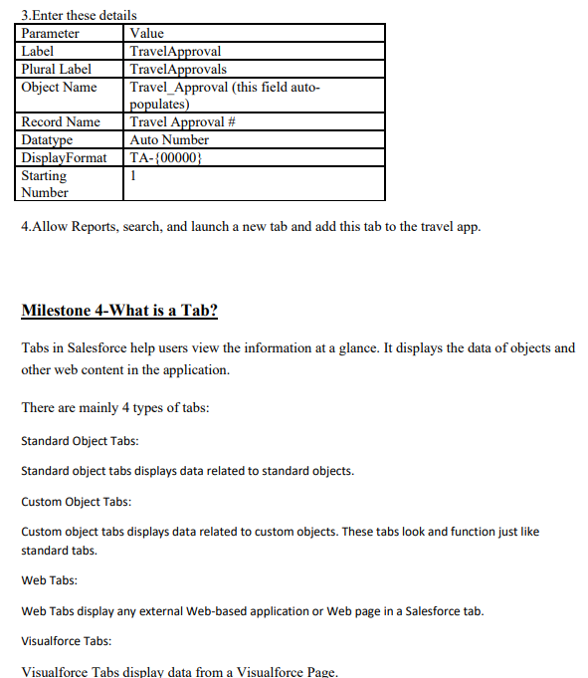

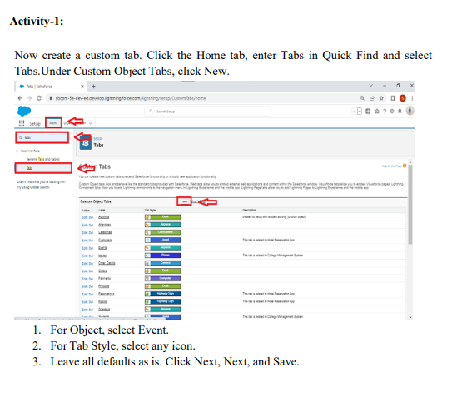

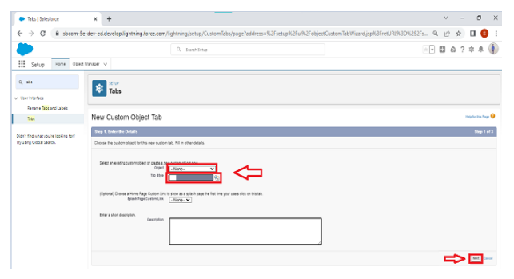

In the same way create other objects such as Attendees, Speaker and Vendor.

**Milestone 4 Create- Fields& Relationships :**

What are fields? Fields in Salesforce represents what the columns represent in relational databases. It can store data values which are required for a particular object in a record. There are 2 types of fields in salesforce:

• Standard fields: There are four standard fields in every custom object that are Created By,

Last Modified By, Owner, and the field created at the time of the creation of an object. These fields cannot be deleted or edited and they are always required. For standard objects, the fields which are present by default in them and cannot be deleted from standard objects are standard fields.

• Custom fields: The Custom fields which are added by the administrator/developer to meet the business requirements of any organization. They may or may not be required

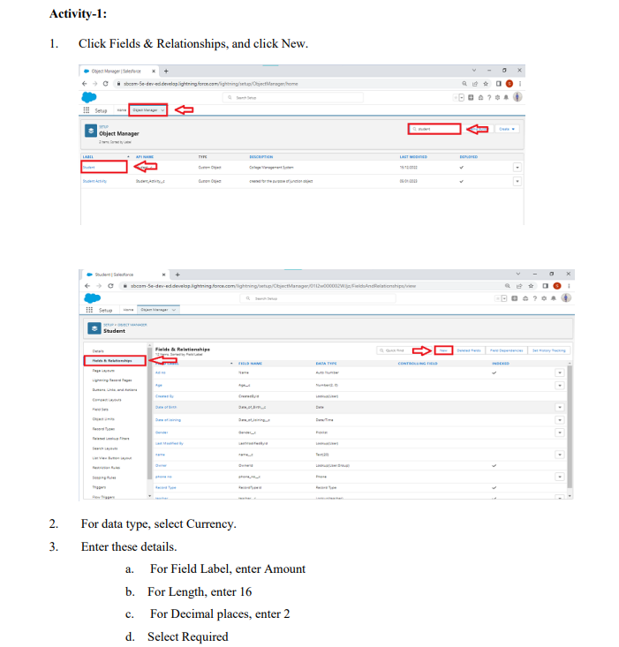

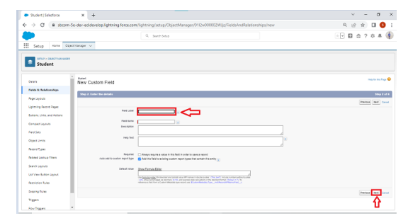

4. Click Next, Next, then Save & New.

**Activity-2:**

**Create the Expense Type field**.

• Select Picklist as the data type.

• Select Enter values, with each value separated by a new line.

• Add these values:(Airfare, Hotel, RentalCars, Meals,Others)

• Select Required.

• Click Next, Next, then Save & New.

**Activity-3: Create the Travel Approval field.**

• Select Master-Detail Relationship data type, click Next.

• Select Travel Approval from the Related To menu.

• Click Next four times, then click Save

**Milestone 5-Import Departments**

In order to complete this milestone, you need to download the reference file https://developer.salesforce.com/files/TravelAppWorkshopFiles.zip?\_ga=2.108173638.5975640 88.1674441525-733189446.1673935386

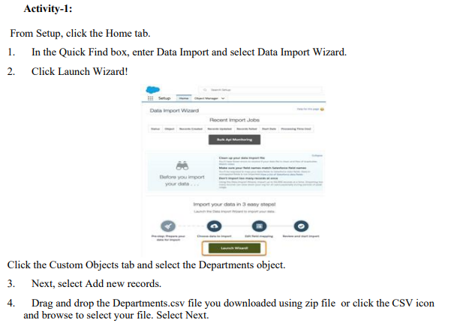

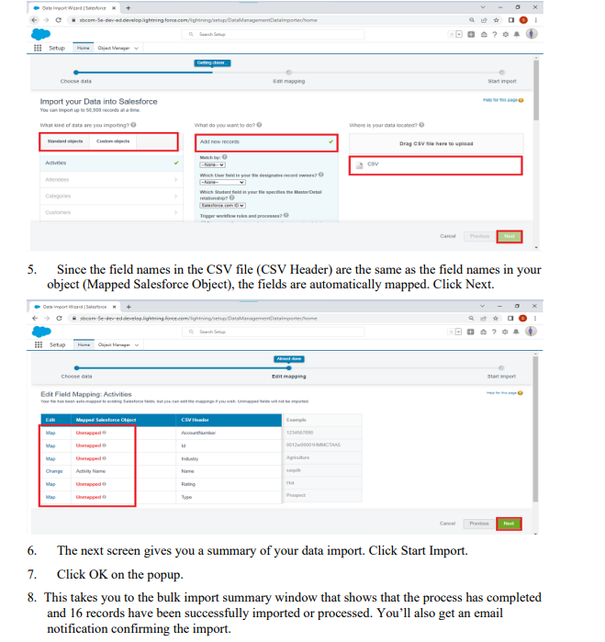

**Milestone 6-Customize User Interface**

In this Milestone we are going to setup the users, customizing the page layouts

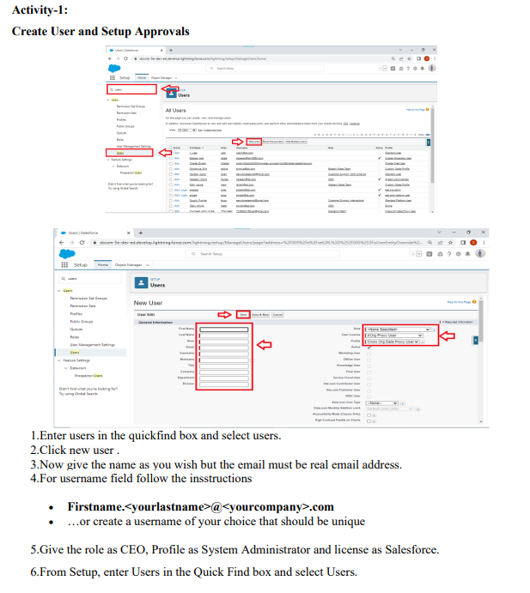

7.Select your user account in the list provided. (Click on your name in the All Users list.)

8.Click Edit.

9.Scroll down to Approver Settings. Set your manager as the user you have created recently.

10.Click Save

**Milestone 7- Use customization**

Customization refers to custom software development and coding to add robust features to your CRM platform. These features can be integrated with your business to have a scalable impact

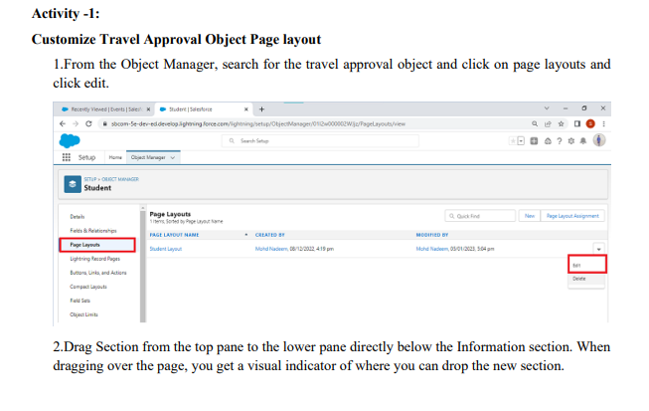

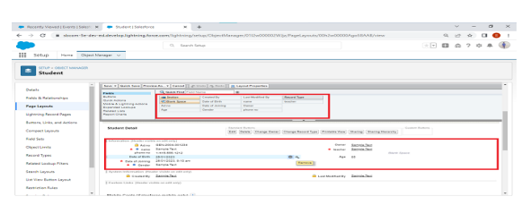

3.Name the section Trip Info, leave the rest of the settings at their default values, then click OK.

4. Drag the Purpose of Trip field from the Information section to the Trip Info section..

5.Drag Trip Start Date and Trip End Date from the top pane into the left-hand column of the Trip Info section.

6.Drag Out-of-State and Destination State from the top pane into the right-hand column of the Trip Info section.

7.Drag the Department field from the left-hand column of the Trip Info section to the right-hand column.

8.Click Save Note: You may need to refresh your browser screen for the changes to show up.

**Milestone 8-Add Business Logic to Travel App**

From this milestone we are going to create validation rules, rollup summary fields, formula fields, workflows and approval process.

**Activity-1:**

**Create Validation Rule**

1.Search for the travel approval object from the object manager and open the object.

2.Click on validation rules and give your rule a name and make sure that the rule is set to active

3.In the error condition formula enter Trip\_End\_Date\_\_c < Trip\_Start\_Date\_\_c.

4.For error location select field and pick trip end date as the location for error

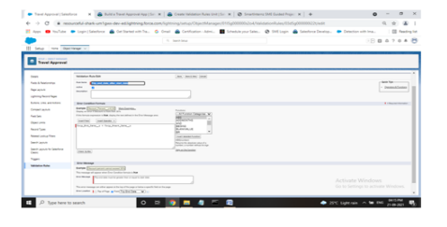

**Activity-2:**

**Create RollUp Summary Fields**

1. From the Travel Approval object, select Fields & Relationships.

2. Click New.

3. Select the Roll-Up Summary data type.

4. Click Next.

5. Enter the following values for the field details

o Field Label: Total Expenses

o Field Name: Total\_Expenses (this automatically gets set when you tab out of the Field Label field

6. Click Next.

7. Configure the roll-up calculation.

o Summarized Object: Expense Items

o Roll-Up Type: SUM

o Field to Aggregate: Amount

o Filter Criteria: All records should be included in the calculation

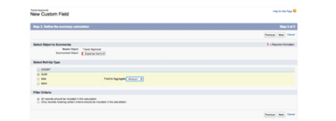

8. Click Next, Next, Save

**Activity-3:**

**Create Formula Fields**

1. First, we need to upload a zip file to your Salesforce environment that contains all the images we use. You should have a file titled StatusImages.zip .

2. Click the Home tab to navigate back to the main setup page.

3. Click Custom Code | Static Resources (or enter Static in the Quick Find to filter down the options).

4. Click New.

5. Enter the following values for your static resource

Parameter: Value

Name : StatusImages

File : StatusImages.zip

Cache Control :Private

6. Now select the travel approval object.

7. Select Fields & Relationships.

8. Click New

9. Select Formula data type.

10. Click Next.

11. Enter the following values: Field Label: Status Indicator Field Name: Status\_Indicator (This automatically gets sent when you tab out of the Field Label field) Formula Return Type: Text

12. Click Next

13. Copy and paste the following formula into the formula editor.

IF( ISPICKVAL( Status\_\_c , 'Approved'), IMAGE("/resource/StatusImages/thumbs-up.png", "Accepted", 20, 20), IF ( ISPICKVAL( Status\_\_c , 'Rejected'), IMAGE("/resource/StatusImages/thumbs-down.png", "Rejected", 20, 20),IMAGE("/resource/StatusImages/draft.png", "In-Process", 20, 20)))

14.Click Next, Next, Save.

**Milestone 10-What are Reports?**

Reports in Salesforce is a list of records that meet a particular criterion which gives an answer to a particular question. These records are displayed as a table that can be filtered or grouped based on any field.

There are 4 types of report formats in Salesforce:

1. **Tabular Reports:**

This is the most basic report format. It just displays the row of records in a table with a grand total. While easy to set up they can’t be used to create groups of data or charts and also cannot be used in Dashboards. They are mainly used to generate a simple list or a list with a grand total.

1. **Summary Reports:**

It is the most commonly used type of report. It allows grouping of rows of data, view subtotal, and create charts.

1. **Matrix Report:**

It is the most complex report format. Matrix report summarizes information in a grid format. It allows records to be grouped by both columns and rows. It can also be used to generate dashboards. Charts can be added to this type of report.

1. **Joined Reports:**

These types of reports let us create different views of data from multiple report types. The data is joined reports are organized in blocks. Each block acts as a subreport with its own fields, columns, sorting, and filtering. They are used to group and show data from multiple report types in different views.

**Report types:**

Report type determines which set of records will be available in a report. Every report is based on a particular report type. The report type is selected first when we create a report. Every report type has a primary object and one or more related objects. All these objects must be linked together either directly or indirectly.

• A report type cannot include more than 4 objects.

• Once a report is created its report type cannot be changed.

There are 2 types of report types:

1. **Standard Report Types:**

Standard Report Types are automatically included with standard objects and also with custom objects where “Allow Reports” is checked.

Standard report types cannot be customized and automatically include standard and custom fields for each object within the report type. Standard report types get created when an object is created, also when a relationship is created.

Note: Standard report types always have inner joins.

1. **Custom Report Types**: Custom report types are reporting templates created to streamline the reporting process. Custom Reports are created by an administrator or User with “Manage Custom Report Types” permission. Custom report types are created when standard report types cannot specify which records will be available on reports.

In custom report types we can specify objects which will be available in a particular report. The primary object must have a relationship with other objects present in a report type either directly or indirectly.

There are 3 types of access levels of folders:

1. **Viewer:**

With this access level, users can see the data in a report but cannot make any changes except cloning it into a new report.

1. **Editor:**

With this access level, users can view and modify the reports it contains and can also move them to/from any other folders they have access level as Editor or Manager.

1. **Manager:**

With this access level, users can do everything Viewers & Editors can do, plus they can also control other user’s access levels to this folder. Also, users with Manager Access levels can delete the report.

From this milestone we are going to import the data and create the reports and dashboards for data visualization in the application

**Activity**

**Add Report**

To create a report:

Go to the app → click on the reports tab

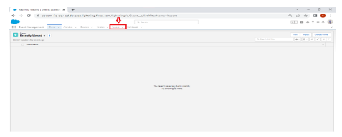

Click New Report

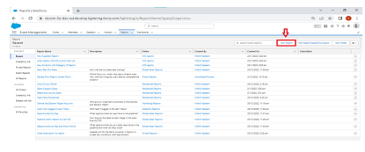

Select report type from category or from report type panel or from search panel → click on start report.

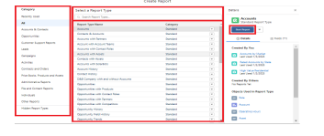

Customize your report, then save or run it

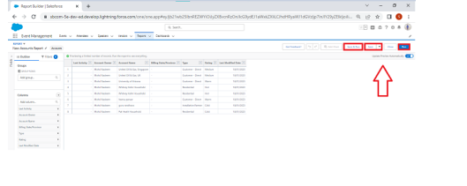

**Milestone 11- Dashboards:**

Dashboards **let you curate data from reports using charts, tables, and metrics.** If your colleagues need more information, then they're able to view your dashboard's data-supplying reports. Dashboard filters make it easy for users to apply different data perspectives to a single dashboard.

**Activity:**

**Create Travel Approvals Dashboard**

1.Click on Dashboards tab from the travel approval application,click on new dashboard

2.Give your dashboard a name and click on +component , select the report which you created .

3.For the data visualization select any of the chart, table etc as your wish

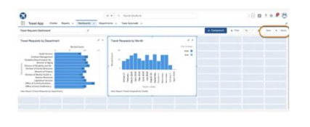

# 4 Trailhead Profile Public URL

**Team Lead –** [https://trailblazer.me/id/suvekavi](https://trailblazer.me/id/suvekavi" \t "_blank)

**Team Member 1-** [https://trailblazer.me/id/smadhavan20](https://trailblazer.me/id/smadhavan20" \t "_blank)

**Team Member 2 -**[https://trailblazer.me/id/swetha1773](https://trailblazer.me/id/swetha1773" \t "_blank)

**Team Member 3-https://trailblazer.me/id/swathi9703**

# 5 ADVANTAGES & DISADVANTAGES

**Advantages**:

1.Approvals on time.

2.Increase compliance and reduce costs.

3.Faster process.

4.Customize approval workflows.

**Disadvantages**:

1.Things are slow in a manual expense approval process

2.Without proper approval and planning, there are chances for last-minute chaos

3.The key information will not reach the relevant person if emails and spreadsheets are used.

# 6 APPLICATIONS

1 This system allows you to request and approve business trips.

2 Flights, hotels and even more external information such as cell phone expenses or car rentals can be entered with the trip request.

3 It is a small sample application for Naturalone.

# 7 CONCLUSION

It has been growing tremendously its employees, customers, offices throughout the world by providing innovative and best ideas. Organizations can use for contact management, customer engagement, workflow creation, task management, and opportunity tracking.

# 8 FUTURE SCOPE

It involves hospitality management, tour management, travel management etc.

It has endless job opportunities in India as large number of heritage, cultural and other tourists throng the country every year.

Many organizations can leverage cloud computing to engage with their current and potential clients and partners more effectively.